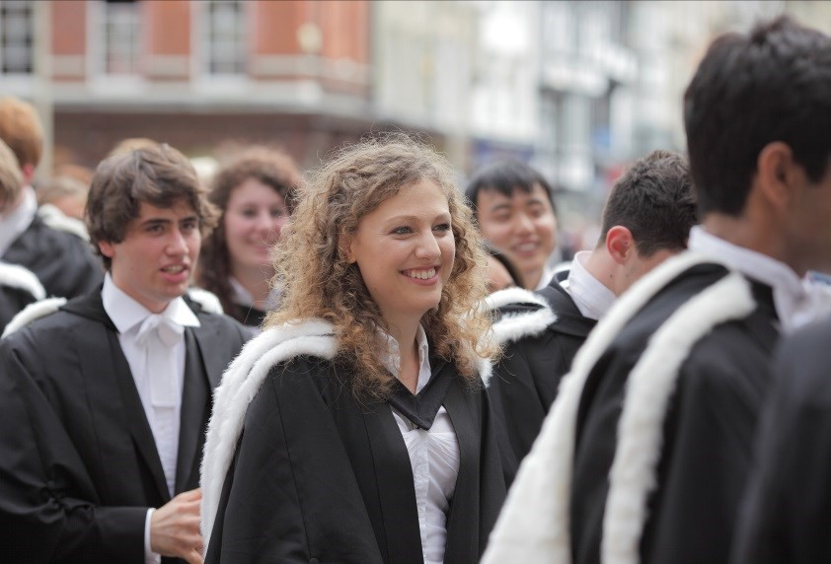
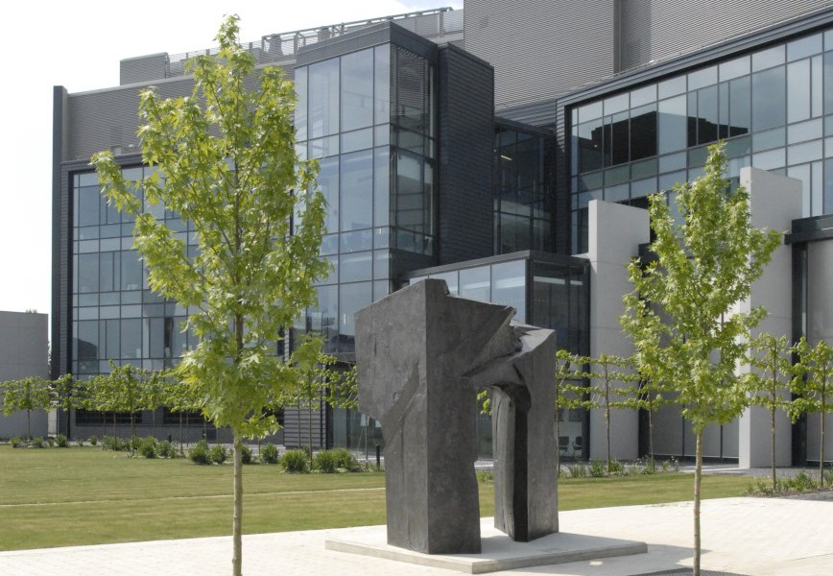
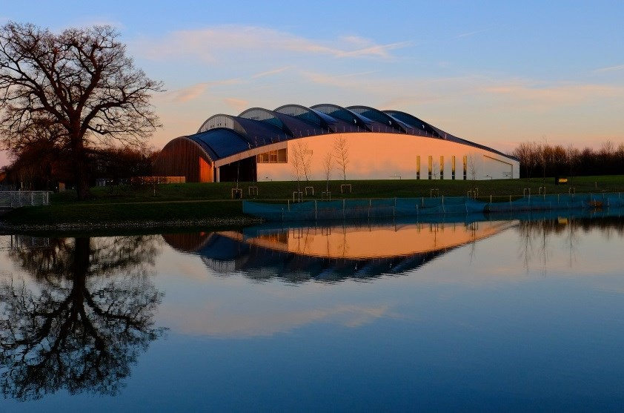
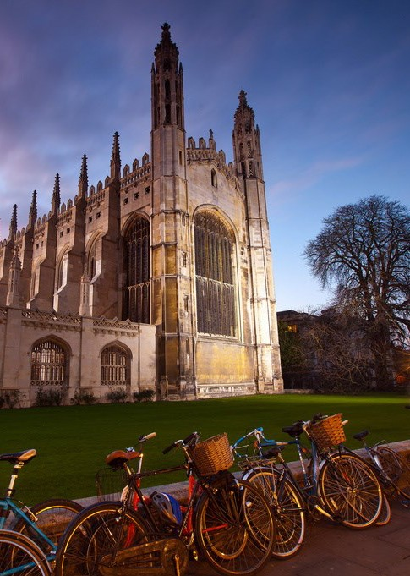

Professional Services Graduate Programme 2020
Information for applicants

The Professional Services Graduate Programme

Emma Stone
Director of Human Resources

The Professional Services Graduate Programme at the University of Cambridge is an important part of the University’s People Strategy that has been developed to support the mission and values of the University.
Our mission is to contribute to society through the pursuit of education, learning, and research at the highest international levels of excellence.
Our core values are:
- freedom of thought and expression; and
- freedom from discrimination

The University aims to attract, recruit and retain the most able
staff across all areas of academic and professional activity to maintain and enhance its world leading reputation, and to develop people’s personal and professional skills and knowledge through-out their careers, providing ongoing support to help them achieve their full
potential in the Cambridge environment.
The Professional Services Graduate Programme provides high calibre graduates with the opportunity to make a significant contribution to the University whilst developing their skills and
knowledge, and building a career in Higher Education.
The University is a stimulating, rewarding and inclusive environment in which to work and if you are interested in being part of our exciting future then read on to find out more about the Professional Services Graduate Programme.

About the programme

The Professional Services Graduate Programme provides motivated and outstanding graduates a foundation for a career in the demanding and inspiring world of university professional services. You will have
the opportunity to develop a range of skills necessary for a successful career within the Higher Education sector.

Induction
A comprehensive induction package will provide you with all of the information you need to help you settle in to your new role and working environment. It will be an ongoing process lasting several weeks and not just a one
-off event that happens on your first day.
You will attend a number of induction activities, including the ‘Welcome to Cambridge’ event, and you will be able to access a range of essential information through our online learning packages, covering various topics, including induction, equal opportunities and health and safety.
You will be encouraged to take an active role in your induction to ensure that it meets your needs effectively.

Placements
The two-year programme is formed of four 6-month placements, giving you exposure to a variety of roles, experiences and perspectives across a number of professional services areas and aims to provide you with the skills and experience to succeed in a career within
the University.
Although responsibilities within each placement will vary, all are stretching and challenging to allow you to develop your skills. The placements will include an interesting and challenging project element as well as incorporating day-to-day operational work allowing you to contribute to the on-going work of the team in which you will based.

Personal, Professional and Career Development
The University offers many opportunities across a broad spectrum to contribute to your personal and professional development, and as a graduate trainee you will benefit from a practical, relevant and structured development programme.
As part of the Professional Services Graduate Programme you will complete a leadership and development programme.
You will also be encouraged to take ownership of your personal development and to build your skills and knowledge. To support this there are a variety of other
training and development activities open to you, including face-to-face briefings, workshops and training courses as well as online modules or courses that combine face-to- face and online elements.
Examples of training courses available include: Inclusive Leadership
Career Development
Leading Your Team Through Change Managing and Developing Effective Teams Communication Skills: Advanced
The encouragement of career development for all staff is one of the University's core values and planning and developing your career will be an ongoing process. The University offers a wide range of tools, support and guidance to help you along the way.

Mentoring
Throughout the programme you will receive mentoring from an experienced University administrator who will provide an additional supportive resource and complement the professional relationships that you will develop within the University.
They will be able to offer knowledge based on their own experience of the University and the work they are involved in. They may offer insights into particular skills and areas of knowledge and support to you in your professional and career development choices and aspirations.

Example placements

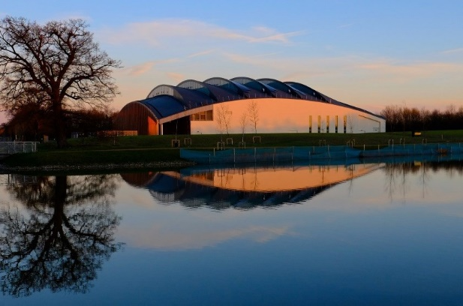

Clinical School Office
The Clinical School Office provides central administrative services to the Head of the School, the Clinical Dean and the Academic Departments and Institutes of the School of Clinical Medicine.
A previous placement involved redesigning the Clinical School Website and actively promoting equipment sharing by developing relevant processes and encouraging departments to promote their research capabilities across the School.

School of Humanities and Social Sciences
The School of the Humanities and Social Sciences includes a wide range of disciplines with differing methodologies and, in terms of student numbers, is the largest of the six Schools in the University.
A previous placement involved looking at how the Faculty of Law’s timetabling process might be streamlined in light of the ongoing work of the Programme Board for Education Space; reviewing the Faculty’s mentoring scheme following recommendations from its Strategic Research Review; reviewing the roles of the Directors of the taught programmes and how best they should fit
together with the role of the Academic Secretary.

Institute of Continuing Education (ICE)
ICE is a constituent part of the University of Cambridge and encourages people in all walks of life to take advantage of continuing education by offering residential, online, weekend, summer, and part-time courses, as well as public lectures
A previous placement involved establishing a robust mechanism for collating and updating library/student resources and embedding them within the Institute’s working practice, as well as producing an online interactive induction resource for part-time extramural students and establishing and facilitating a student working group to influence the identification and acquisition of appropriate resources.

Human Resources (HR) Division
The HR Division supports the achievement of excellence in education, learning and research via the recruitment, retention, reward, recognition and development activities undertaken with and for University staff.
A previous placement gave the opportunity to acquire knowledge, skills and practical experience in three core areas of Human Resources: Employee Relations, Policy and Remuneration. This included supporting the development of a new reward strategy for the University and related project work.

Finance Division
The Finance Division provides financial services for departments and supports everyday transactions that affect individuals across the University.
A previous project involved reviewing and enhancing the planning process, information flows and support processes provided to the Finance Committee and sub- committees.

University Library (UL)

The University Library’s collection is an extraordinary accumulation of several million books, maps, manuscripts and journals, augmented by an ever- increasing range of electronic resources, which now,
through its digitisation projects, reaches new audiences across the world.
A previous placement gave the opportunity to develop a broad understanding of the professional services support underpinning library services both within the main UL building and across more than 20 subject libraries in a wide range of disciplines, with a specific project around library policy and procedures.

What we are looking for

Qualifications:
You will have graduated as an undergraduate or postgraduate in any discipline, within 5 years of your application. If you do not have a postgraduate qualification, you must have achieved at least a minimum 2:1 in your undergraduate degree. If you are in your final year of undergraduate study, any offer of employment would be conditional on you obtaining at least a 2:1 degree classification.

Eligibility
You must be eligible to work in the UK for the length of the programme

Key skills and qualities:
Excellent oral and written communication skills Strong research, analysis and report writing skills Strong interpersonal and team working skills
Excellent planning, prioritising and organisational skills
Ability to apply skills and knowledge in new environments and contexts Passionate about driving own personal and professional development

Behavioural Attributes:
The University’s Behavioural Attributes are how we describe a range of individual characteristics required for a role. Behavioural attributes are made up of a range of motives, traits, skills and knowledge and give a clear understanding of the behavioural attributes valued by the University. The Level C Behavioural Attributes (Level D for People Development) give an indication of what we would expect you to be able to demonstrate.
Communication: Communicates effectively and appropriately with a variety of stakeholders including
external partners, teams, colleagues and contacts.
Relationship Building: Maintains working relationships with existing partners. Works effectively within a team or work group as appropriate.

Valuing Diversity: Considers and respects the ideas, circumstances and feelings of others. Treats everyone with fairness and respect, adhering to the principles of diversity and inclusion.

Achieving Results: Solves work-related problems effectively. Provides support and contributes to the performance of the institution. Manages own workload and, where applicable, the workload of others.

Strategic Focus: Implement’s the University’s strategy and planning activity within the team. Supports the University’s mission and priorities.

People Development: Takes ownership of own performance and development. Assists the develop- ment of others where appropriate.

Negotiating and Influencing: Persuades and influences peers and managers through consideration
of their interests, involvement and consultation.

Innovation and Change: Develops and promotes new ways of working to improve performance within team and institution.

Full definitions, including examples of positive indicators, can be found at: www.admin.cam.ac.uk/offices/hr/ policy/behavioural/attributes/

Professional Services

Professional Services
Professional Services provide the infrastructure that helps the University run effectively and works to support the research, learning and teaching activity of the University, its staff and students.
At the heart of professional services is the Unified Administrative Service.

Unified Administrative Service
The University’s central Unified Administrative Service (UAS) works in partnership with Schools, Faculties and Departments, providing core professional and
administrative services in support of Cambridge’s academic and charitable mission. It also offers a range of expertise and skills that help support the development and implementation of policy across a number of
functional areas.
The UAS is led by the Registrary, as the University's Principal Administrative Officer, and consists of the following divisions:
Academic Division
Estate Management Division Finance Division
Health, Safety, and Regulated Facilities Division Human Resources Division
Registrary's Office
Administrative staff within a number of these divisions, especially the Academic Division and Finance Division, are often physically located in Schools, Faculties and Departments, and are fully involved in their day-to-day operation.

Human Resources (HR) Division
The role of Professional Services Graduate Trainee is within the HR Division, although placements will be in a variety of areas.
The HR Division supports the achievement of excellence in education, learning and research via the recruitment, retention, reward, recognition and development activities undertaken with and for University staff. In addition, the Division seeks to ensure that the University continues to maintain and enhance
its reputation as a leading employer.
Further details about the Division can be found at: https://www.hr.admin.cam.ac.uk/

Terms of appointment

Salary
The starting salary is £29,176. This will increase to £30,046 in year 2 of the programme.

Tenure and probation
Appointment will be made on a fixed- term basis of 2 years as you will be appointed to undertake a specific programme of finite duration.

Hours of Work
and Working Pattern
The hours of work for the position are full-time, Monday to Friday.

Pension
You will automatically be enrolled to become a member of USS (Universities Superannuation
Scheme) – a defined benefits pension scheme. For further information please visit:
www.pensions.admin.cam.ac.uk/.

Annual leave
Full time employees are entitled to annual paid leave of 6.6 weeks (or 33 days for those working full time), plus public holidays.

General information

Pre-employment checks

Right to work in the UK
We have a legal responsibility to ensure that you have the right to work in the UK before you can start working for us. If you do not have the right to work in the UK already, any offer of employment we make to you will be conditional upon you gaining it.

Health declaration
Once an offer of employment has been made the successful candidate will be required to complete a work health declaration form.

Qualifications
The qualifications needed are essential. Please note that if you are offered the post you will be asked to provide your relevant original certificates of these qualifications.

References - offers of appointment will be subject to the receipt of satisfactory references.

Information if you have a disability The University welcomes applications from individuals with disabilities.
We are committed to ensuring fair
treatment throughout the recruitment process. We will make adjustments to enable applicants to compete to the best of their ability wherever it is reasonable to do so and, if successful, to assist them during their employment. Information for disabled applicants is available at http://
www.admin.cam.ac.uk/offices/hr/staff/
disabled/

We encourage you to declare any disability that you may have, and any reasonable adjustments that you may require, in the section provided for
this purpose in the application form. This will enable us to accommodate your needs throughout the process as required. However, applicants and employees may declare a disability at any time.

If you prefer to discuss any special arrangements connected with a disability, please contact Miranda Carr, Learning and Development Consultant, by e-mail:
Miranda.Carr@admin.cam.ac.uk

Our mission is to contribute to society through the pursuit of education, learning, and research at the highest international levels of excellence. Our core values are:

- freedom of thought and expression; and
- freedom from discrimination.

The University

The University of Cambridge is one of the world’s oldest and most successful universities. We are a renowned centre for research, education, and scholarship that makes a significant
contribution to society. The University is consistently ranked amongst the top universities in the world. Our affiliates have won more Nobel Prizes than any other University.

Our sustained pursuit of academic excellence is built on a long history of first-class teaching and research within a distinctive collegiate system. For eight centuries our ideas and innovations have shaped the world. Our principal goal is to remain one of the world’s leading universities in an increasingly competitive global higher education sector. Today the University of Cambridge is at the centre of a
cluster of over 4,300 businesses employing 58,000 people. Our capital investment projects include the West Cambridge site, the North West Cambridge development and the growth of the Biomedical Campus in the south of the city. The North West Cambridge development includes the opening of a primary school – the first in the UK to be managed by a University. So we are deeply embedded in, and
committed to serving, our local community. These are all conspicuous signs of a University that is not

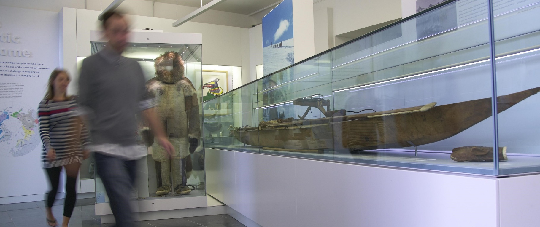

About us

The University is one of the world's leading academic centres. It comprises 150 faculties and departments, together with a central administration and other institutions. Our
institutions, museums and collections
are a world-class resource for researchers,
students and members of the public representing one of the country’s highest concentrations of internationally important collections.
The University has an annual income of £1.66 billion. Research income, won competitively from the UK Research Councils, the European Union (EU), major charities and industry, exceeds £400 million per annum and continues to grow.

The Colleges and the University remain committed to admitting the best students regardless of their
background and to investing considerable resources both in widening access and financial support.

The 31 Colleges are self-governing, separate legal entities which appoint their own staff. Many academic staff are invited to join a College as a Teaching Fellow, which provides a further social and intellectual dimension. The Colleges admit students, provide
student accommodation and deliver small group teaching. The University awards degrees and its faculties and departments provide lectures and seminars for
students and determine the syllabi for teaching and conducting research.

The University’s estate is undergoing the most significant transformation in its history. Cambridge has been able to create a new science and technology campus to the west of the city centre, and is now expanding further to the north west of Cambridge including investing in affordable homes for University key workers and community
facilities. Even with our continued development, the University remains within walking or cycling distance across the campus. The University is a major partner on the Cambridge Biomedical Campus and we continue to redevelop our historic city centre sites demonstrating our determination to ensure that we can offer the best
facilities and opportunities for our staff and students.

Our instinct for seeking out excellence and setting up enduring and mutually beneficial collaborations has led us to establish strategic partnerships across the globe.
Whether it is the successful Cambridge-Africa Programme involving universities in Ghana, Uganda and elsewhere on the African continent; or the close association with the government of India to pursue new research in crop science; or the creation, with Germany’s Max Planck

Our ideas and innovations have shaped the world. Our campaign, 'Dear World... Yours, Cambridge', will raise
£2 billion to help us shape all our futures.
Institutes, of a Cambridge-based centre for the study of ethics, human economy and social change – international partnerships are now an inextricable part of the University’s make-up.

Working at the University

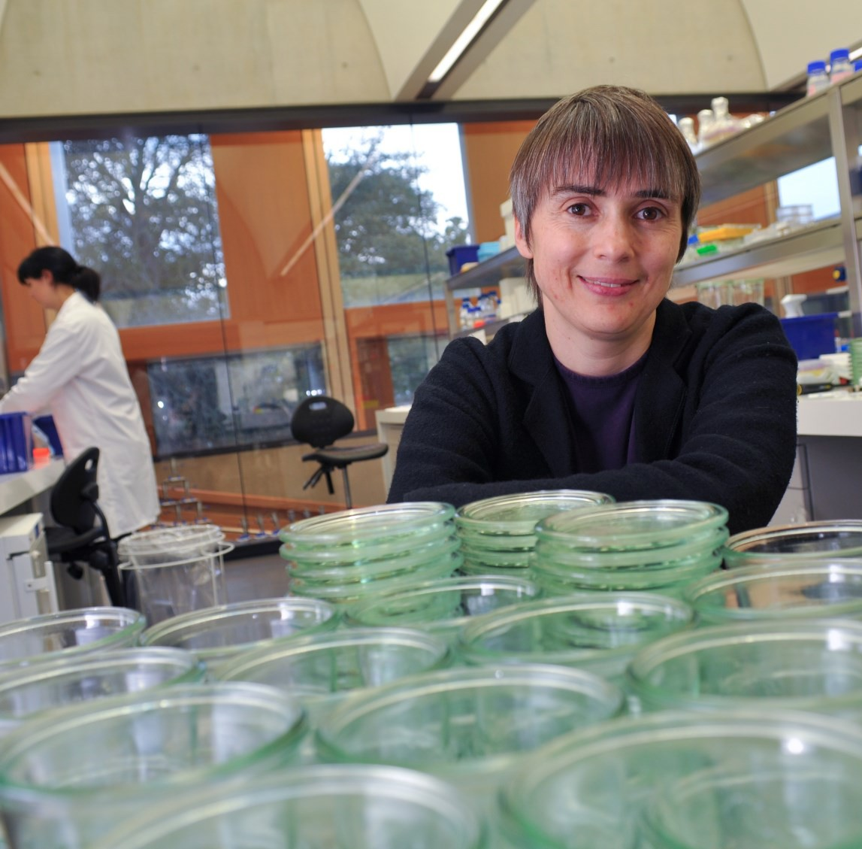
Working at Cambridge you will join a diverse, talented and innovative community, with more than 18,000 students and over 11,000 staff from all walks of life and corners of the world.
The University continually explores strategies to attract and retain the best people. It is committed to supporting its staff to achieve their best. We are a fair, diverse and inclusive society and we believe our staff are our
greatest asset. There is strong commitment to developing institutional leadership and supporting and encouraging staff development at all levels.
Furthermore, the University’s Athena SWAN award recognises and celebrates good practice in recruiting, retaining and promoting women. We offer a variety of roles including academic, research, professional, managerial and support roles. We also offer extensive benefits and excellent learning opportunities within a stimulating working environment. The University has signed up to the Race Equality Charter, a notional framework for improving the representation, progression and success of minority ethnic staff and students within higher education.

Living in Cambridge

Cambridge is rich in cultural diversity. From beautiful University and College buildings, museums
and art galleries, quaint gardens and punts on the River Cam, to a vibrant restaurant and café scene, our employees are surrounded by the wonderful features of this unique city.
If you prefer the faster pace of life, London is a 45 minute train journey away. For those travelling from overseas, Stansted Airport is just 45 minutes away and Heathrow Airport under 2 hours away.
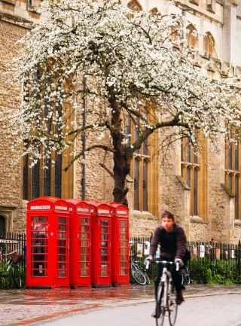
The University is a short distance from a host of other attractions such as Ely Cathedral, Newmarket Races and various wildlife parks and stately homes.
Cambridge is also within easy reach of the beautiful Broads and coastlines of Norfolk and Suffolk.
Further information about attractions in and around Cambridge can be found at Visit Cambridge, the official tourism website for the city.

What Cambridge can offer

We offer a comprehensive reward package to attract, motivate and retain high performing staff at all levels and in all areas of work. The University offers a wide range of competitive benefits, from family leave entitlement, to shopping and travel discount schemes. Our generous annual leave package
contributes to the positive wellbeing of our University employees. Sabbatical leave enables academics to focus on research and scholarship, whilst still maintaining their full salary. The University also has a career break scheme for academic and academic- related staff, with additional flexible working policies for all other staff.

CAMbens employee benefits
We offer a CAMbens scheme for University employees, providing access to online and in-store shopping discounts and cashback. With more than
2,000 participating retailers, employees can save money on a wide range of household expenses, from groceries and clothes, to holidays and insurance and much more. A range of local discounts are also available, helping employees to save money whilst also supporting local Cambridge businesses. CAMbens Cars and CAMbens
Cycle to Work salary sacrifice schemes are also available, which enable employees to save money on transport
costs. A 10% discount rate on the purchase of train season tickets, bulk buy tickets and an interest free travel to work loan are also available for staff of the University of Cambridge.

Family-friendly policies
The University recognises the importance of
supporting its staff. We have a range of family-friendly policies to aid employees’ work-life balance including a generous maternity, adoption and shared parental leave entitlement of 18 weeks full pay and emergency family care support via My Family Care. In addition, our Ofsted rated ‘outstanding’ workplace nurseries, childcare vouchers, a childcare salary sacrifice scheme and a high
quality holiday play scheme are available to help support University employees with caring responsibilities.
The Newcomers and Visiting Scholars Group is an organisation within the University run by volunteers whose aim is to help newly arrived wives, husbands, partners and families of Visiting Scholars and members of the University to settle in Cambridge and give them an opportunity to meet local people.

Your wellbeing
The University’s Sport Centre, Counselling Services and Occupational Health are just some of the support services available to University employees to promote their physical and mental wellbeing. There are many societies in Cambridge catering for almost every taste and interest. Whether you want to take part in a sport,
participate in music or drama, pursue a hobby, or join a political group, you will almost certainly find that a society exists for this purpose.

The University also hosts the Cambridge Science Festival and Cambridge Festival of Ideas, as well as Open
Cambridge weekend, which together attract over 50,000 visitors per year. The festivals are a great opportunity
to get your first taste of public engagement, through volunteering, supporting hands-on activities or proposing a talk.

What Cambridge can offer

Pay and benefits
The University salary structure includes automatic service-related pay progression in many of its grades and an annual cost of living increase. In addition to this, employees are rewarded for outstanding contribution
through a number of regular pay progression schemes. The University offers attractive pensions schemes for employees, with an additional benefit of a salary exchange arrangement providing tax and national insurance savings. Payroll giving is also a simple,
tax-efficient way for employees to make monthly
donations to charity.

Relocating to Cambridge
The University Accommodation Service exists to help employees in their search for a rental home in Cambridge. A new University development at North West Cambridge called Eddington offers subsidised rented accommodation to University staff. The development consists of high quality furnished one and two bedroom apartments. For more information about the development and how to apply please visit the
website www.nwcambridge.co.uk
The importance of helping individuals settle into a new
area is also recognised by the University. The Shared Equity Scheme https://www.hr.admin.cam.ac.uk/pay-
benefits/cambens-employee-benefits/financial/shared-
equity-scheme provides financial assistance to qualifying new members of staff with the purchase of living accommodation, where they have to relocate to take up their appointment. Removal expenses are also available for qualifying new members of staff.
Whether it is understanding the molecular basis of neurodegenerative diseases, or
helping farmers in India increase their yield, or discovering better ways to live in large cities – I know that what we do in Cambridge affects lives, and livelihoods, the world over.
Vice Chancellor Professor Sir Leszek Borysiewicz, 2016

Equality & diversity
The University has a vibrant and varied community. We support and encourage under-represented groups and we value diversity. We welcome applications from individuals with disabilities. Our recruitment and
selection procedures follow best practice. We have an Equal Opportunities Policy, along with a range of diversity
networks for women, black and minority ethnic and

lesbian, gay, bisexual and transgender staff. More details are available here: http://www.equality.admin.cam.ac.uk/

Development opportunities
We support new employees to settle in through various activities. The encouragement of career
development for all staff is one of the University's values and we put this into practice through various services and initiatives. Our Personal and Professional Development Department provides development opportunities and courses for all University employees. These include face- to-face sessions, online learning modules and webinars. Employees may also apply for financial support to undertake training that will lead to a qualification. We offer reduced staff fees for University of Cambridge graduate courses and the opportunity to attend lectures and seminars held by University departments and
institutions.

The application process

Opening date for applications:
- 13 January 2020
- Apply at www.jobs.cam.ac.uk

Closing date for applications:
- 21 February 2020
- Once the application window has closed applications will be shortlisted and a small number of applicants will be invited to an assessment day

Assessment day:
- 23 April 2020
- Applicants will be asked to complete a series of exercises incorporating a desk- based exercise, presentation and interview
- Applicants who attend the assessment day will be informed within two weeks whether or not they have been successful

Successful applicants will start the Professional Services Graduate Programme on:
- 21 September 2020

How to apply
Applications should be submitted online via the University of Cambridge jobs page www.jobs.cam.ac.uk by clicking “Apply online” in the job advert. You will need an email address to register for our online system.
You will need to upload a completed Application Form together with your CV. Covering letters are not required.
Informal enquiries are welcomed and should be directed to: Miranda Carr, Learning and Development Consultant.
Email: miranda.carr@admin.cam.ac.uk
If you have any queries regarding the application process please contact Miranda Carr.
Applications open 13 January 2020
The closing date for applications is 21st February 2020

